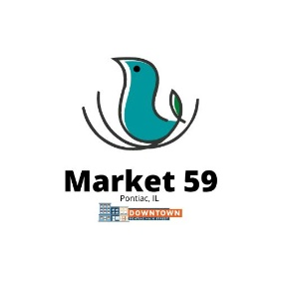
Market 59 Business Incubator Program
Vendor Application
Business Name: _______________________________________________________________________
Primary Contact: _________________________________ Phone: _______________________________
Email: _______________________________________________________________________________
Address: _____________________________________________________________________________
City: _____________________________________ State: __________________ Zip: ________________
Do you currently operate a retail business? Yes □ No □ Business Tax ID/EIN: _____________________
Website: _________________________________________________________________________________
Social Media: ____________________________________________________________________________________
_____________________________________________________________________________________
Please describe your items to be sold: ______________________________________________________
_______________________________________________________________________________________________________________________________________________________________________________________________________________________________________________________________
If you currently operate a retail business, where do you house it and how long have you been in business?
__________________________________________________________________________________________________________________________________________________________________________

Why do you want to participate in the Market 59 Business Incubator Program? ____________________________________________________________________________________________________________________________________________________________________________________________________________________________________________________________________________________________________________________________________________________
Please attach between 5 and 15 photos representing your business.
Please attach your business plan if created.
Please attach any necessary licenses (ie: food establishment permit).
Your application will not be considered unless it is filled out entirely with those items attached.
Is there anything else the selection team should know when reviewing your application?
_____________________________________________________________________________________
_____________________________________________________________________________________
_____________________________________________________________________________________
_____________________________________________________________________________________

Please submit the completed application via the online form or to Pontiac City Hall (115 W. Howard St, Pontiac, IL 61764). Incomplete applications will not be considered. Please note that all information in this application is subject to the final lease agreement.
Thank you for your interest in Downtown Pontiac and Market 59!
Each application will be reviewed by the Community Development Team to ensure they meet standards. Applicants will be notified beginning December 15th if their application has been approved. Once approved, a final lease will be provided, and location assignments will be given by staff. Please note full payment with the signed lease agreement is required when lease is signed. You may begin setting up your shop January 15th, with an opening day of February 1st. Last day of business is October 31st, allowing two weeks to vacate and get moved to permanent location by November 15th. This will allow you to be a highlighted NEW business on Small Business Saturday.
No refunds for vendor cancellations will be given. Vendors may not sub-let their location to another vendor. Vendors who do so will forfeit their lease and will not receive a refund. Only vendors listed and approved on the original application will be allowed.

